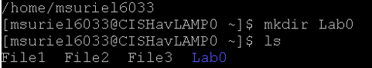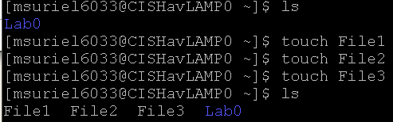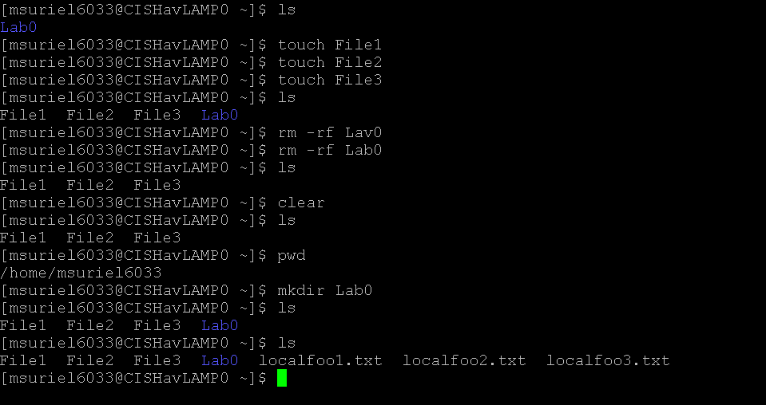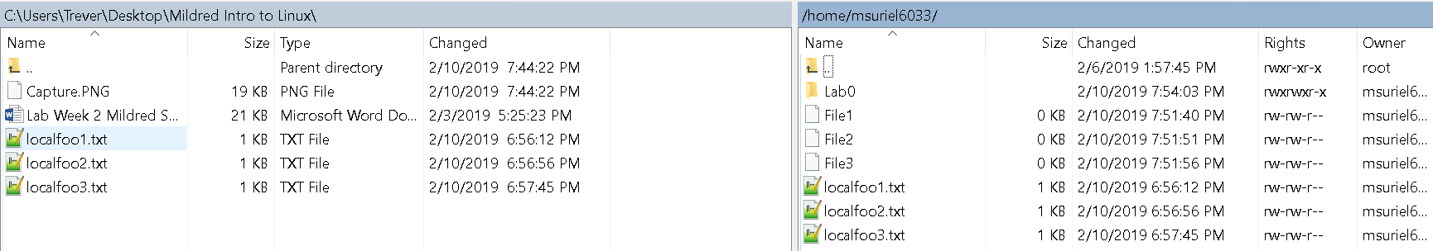

Files being displayed in the server

Files moved over to server from WinSCP

3 files and Subdirectory created: File1, File2, File3

**Common Commands**